

**Data Science & Analytics - Internship**

| **Intern’s Name** | **Email ID** |
| --- | --- |
| **Sumaiya Tasnim** | [sumaiyaa.tasnim.18@gmail.com](mailto:sumaiyaa.tasnim.18@gmail.com) |

**Introduction:**  
The task focuses on analyzing marketing campaign performance data to uncover actionable business insights. The primary aim is to explore customer engagement, revenue contribution, and response behavior across campaigns. By transforming raw campaign data into meaningful visual representations, the project emphasizes storytelling through data, helping identify high-performing customer segments, top-spending groups, and trends across products and demographics.

**Objectives:**

* Understand the structure and components of the marketing dataset.
* Perform data cleaning and transformation for accurate visualization.
* Identify top-performing campaigns, high-engagement segments, and revenue-driving products.
* Develop interactive dashboards using DAX-based KPIs and visuals.
* Derive insights to support strategic campaign optimization and decision-making.

**Assigned Dataset:**

| **Raw Dataset** | **Cleaned Dataset Exported as** |
| --- | --- |
| “marketing_data.csv” | “Marketing_Campaign_Data.csv” |

**Tools Used:**

| **Tool** | **Purpose** |
| --- | --- |
| **Power BI** | To build professional, interactive dashboards for campaign performance analysis and visualization. |
| **Visual Studio (Python - Jupyter Notebook)** | For quick data cleaning, transformation, and exploratory analysis before dashboard creation. |

**Expected Outcome:**

* A fully cleaned and transformed dataset ready for analysis.
* Development of key visuals: Donut, Pie, Line, Clustered Bar, Clustered Column, and Gauge charts.
* Identification of high-response customer segments (Education, Marital_Status, Income), top-spending groups (MntWines, MntFruits, MntMeatProducts, etc.), and campaign engagement trends (Total_Engagements, Response).
* Implementation of DAX measures for Total Engagements, Total Revenue, Cost per Engagement (CPE), Engagement Rate.

Creation of an interactive dashboard that enables dynamic filtering by Year (Dt_Customer), Marital_Status, Education, Country, Kidhome, Teenhome, and Response.

* Actionable insights for improving future marketing campaigns and optimizing ROI.

**Dashboard Flow:**

Trend → Segmentation → Efficiency → Revenue → Improvement

**Explanation of the Flow:**

* **Trend** – Analyze campaign performance over time (e.g., total engagements, revenue by month).
* **Segmentation** – Break down performance by customer demographics (Education, Marital Status, Income) or country.
* **Efficiency** – Evaluate cost-effectiveness using metrics like Cost per Engagement (CPE) and Engagement Rate.
* **Revenue** – Assess financial impact via Total Revenue, Total Spending, and Average Purchases per Customer.
* **Improvement** – Identify opportunities for optimization, such as underperforming segments or low-response campaigns, and suggest actionable recommendations.

**My Github Link:** <https://github.com/sumaiya-tasnim-18>

***(All my projects are available on my Github Account)***

**Summarizing all the data cleaning steps:**

| **Step** | **Column(s)** | **Issue / Observation** | **Action Taken** | **Result** |
| --- | --- | --- | --- | --- |
| 1 | Income | Some missing / non-numeric values | Converted to numeric; replaced invalid/missing with 0 | All values numeric, no missing |
| 2 | Dt_Customer | Date format inconsistent; previous conversion failed | Converted to datetime; invalid entries replaced with current date | All values valid datetime |
| 3 | Marital_Status | Invalid/unrealistic entries (YOLO, Alone, Absurd) | Replaced invalid entries with "Other" | Only valid categories + "Other" |
| 4 | Education | Typo: "2n Cycle" | Corrected to "2nd Cycle" | All entries consistent |
| 5 | Country | Country codes (SP, US, etc.) | Replaced codes with full country names | All entries human-readable |
| 6 | All Columns | Missing values | Checked & handled (Income: 0, others no missing) | No missing values |
| 7 | All Columns | Duplicates | Checked & removed (none found) | No duplicates |
| 8 | All Columns | Data types | Corrected: numeric → numeric, dates → datetime, categorical kept as object | All columns have correct types |

**Data Structure:**

| **Column Name** | **Data Type** | **Column Name** | **Data Type** | **Column Name** | **Data Type** |
| --- | --- | --- | --- | --- | --- |
| ID | int64 | Year_Birth | int64 | Education | object |
| Marital_Status | object | Income | float64 | Kidhome | int64 |
| Teenhome | int64 | Dt_Customer | datetime64[ns] | Recency | int64 |
| MntWines | int64 | MntFruits | int64 | MntMeatProducts | int64 |
| MntFishProducts | int64 | MntSweetProducts | int64 | MntGoldProds | int64 |
| NumDealsPurchases | int64 | NumWebPurchases | int64 | NumCatalogPurchases | int64 |
| NumStorePurchases | int64 | NumWebVisitsMonth | int64 | AcceptedCmp3 | int64 |
| AcceptedCmp4 | int64 | AcceptedCmp5 | int64 | AcceptedCmp1 | int64 |
| AcceptedCmp2 | int64 | Response | int64 | Complain | int64 |
| Country | object |  |  |  |  |

**Overall Review:**

| **Dataset Version** | **Dataset Name** | **Total Rows** | **Total Columns** | **Notes / Status** |
| --- | --- | --- | --- | --- |
| **Raw Dataset** | marketing_data.csv | 2240 | 28 | Original dataset; Income had 24 missing values, Dt_Customer inconsistent, Marital_Status and Education had invalid/typo entries, Country in codes, mixed data types |
| **Exported Cleaned Dataset** | Marketing_Campaign_Data.csv | 2240 | 28 | Missing values handled (Income filled with 0), Dt_Customer converted to datetime, invalid Marital_Status replaced with "Other", "2n Cycle" corrected to "2nd Cycle", country codes replaced with full names, all data types corrected, dataset ready for analysis |

**Marketing Campaign Performance Dashboard KPI Summary:**

| **Column Name** | **DAX Formula** | **Business Question Addressed** | **Why It’s Important / Insight** |
| --- | --- | --- | --- |
| **Total Engagements** | SUM('Marketing_Campaign_Data'[AcceptedCmp1]) + SUM('Marketing_Campaign_Data'[AcceptedCmp2]) + SUM('Marketing_Campaign_Data'[AcceptedCmp3]) + SUM('Marketing_Campaign_Data'[AcceptedCmp4]) + SUM('Marketing_Campaign_Data'[AcceptedCmp5]) + SUM('Marketing_Campaign_Data'[Response]) | How many customers engaged with the campaigns? | Measures overall campaign engagement; helps understand campaign reach and effectiveness. |
| **Total Revenue** | SUM('Marketing_Campaign_Data'[MntWines]) + SUM('Marketing_Campaign_Data'[MntFruits]) + SUM('Marketing_Campaign_Data'[MntMeatProducts]) + SUM('Marketing_Campaign_Data'[MntFishProducts]) + SUM('Marketing_Campaign_Data'[MntSweetProducts]) + SUM('Marketing_Campaign_Data'[MntGoldProds]) | How much revenue did the campaigns generate? | Shows financial impact of campaigns; identifies which campaigns/products drive sales. |
| **Cost per Engagement (CPE)** | DIVIDE([Total_Revenue], [Total_Engagements], 0) | How cost-efficient was each engagement? | Evaluates cost-effectiveness; lower CPE means better ROI per engagement. |
| **Engagement Rate** | DIVIDE([Total_Engagements], COUNT('Marketing_Campaign_Data'[ID]), 0) | What portion of customers engaged with campaigns? | Acts as a proxy for campaign CTR; shows overall effectiveness at reaching the audience. |
| **Total Spending** | SUM('Marketing_Campaign_Data'[MntWines]) + SUM('Marketing_Campaign_Data'[MntFruits]) + SUM('Marketing_Campaign_Data'[MntMeatProducts]) + SUM('Marketing_Campaign_Data'[MntFishProducts]) + SUM('Marketing_Campaign_Data'[MntSweetProducts]) + SUM('Marketing_Campaign_Data'[MntGoldProds]) | How much did customers spend in total? | Shows overall monetary contribution; useful for revenue comparison across campaigns or segments. |
| **Total Purchases** | SUM('Marketing_Campaign_Data'[NumDealsPurchases]) + SUM('Marketing_Campaign_Data'[NumWebPurchases]) + SUM('Marketing_Campaign_Data'[NumCatalogPurchases]) + SUM('Marketing_Campaign_Data'[NumStorePurchases]) | How many purchases were made by customers across channels? | Helps track customer activity; indicates cross-channel engagement and sales volume. |

**Marketing Campaign Performance Dashboard Visualization Summary:**

| **Visualization Title** | **Chart Type** | **DAX / Measure Used** | **Business Questions Addressed** | **Why It’s Important / Insight** |
| --- | --- | --- | --- | --- |
| Engagement Rate by Education | Donut Chart | Engagement Rate = DIVIDE([Total_Engagements], COUNT('Marketing_Campaign_Data'[ID]), 0) | Which customer segments engage the most based on education level? | Identifies high-response education segments; helps target campaigns more effectively. |
| Total Engagement by Month | Line Chart | Total Engagements = SUM('Marketing_Campaign_Data'[AcceptedCmp1]) + SUM([AcceptedCmp2]) + … + SUM([Response]) | How well did the ad campaign perform over time? | Shows engagement trends and campaign effectiveness month-to-month; highlights peaks and dips. |
| **Total Engagement and Revenue per Customer by Month** | Line & Column Combo Chart | Total Engagements = SUM('Marketing_Campaign_Data'[AcceptedCmp1]) + … + SUM([Response]); Revenue per Customer = DIVIDE([Total_Revenue], COUNT('Marketing_Campaign_Data'[ID]), 0) | How do customer engagement and revenue vary monthly? | Shows the relationship between engagement and revenue trends; helps align campaign timing with peak performance. |
| Customer Spending by Product | Pie Chart | Total Spending = SUM([MntWines]) + SUM([MntFruits]) + SUM([MntMeatProducts]) + SUM([MntFishProducts]) + SUM([MntSweetProducts]) + SUM([MntGoldProds]) | Which products generated the most revenue from customers? | Identifies top-selling product categories; helps optimize product-focused campaigns. |
| **Customer Interaction Distribution by Channel** | Pie Chart | SUM([NumWebPurchases]) + SUM([NumCatalogPurchases]) + SUM([NumStorePurchases]) + SUM([NumDealsPurchases]) + SUM([NumWebVisitsMonth]) | How do customers interact across different purchase and visit channels? | Provides visibility into preferred interaction channels; supports multichannel strategy and marketing optimization. |
| Income by Marital Status | Clustered Bar Chart | Sum of Income | How does income vary across different marital status groups? | Reveals which marital segments have higher spending potential; helps target campaigns based on income. |
| Campaign Engagement by Country | Clustered Column Chart | Total Engagements = SUM([AcceptedCmp1]) + SUM([AcceptedCmp2]) + … + SUM([Response]) | Which regions showed the highest campaign engagement? | Highlights high-performing countries; guides regional marketing strategy and resource allocation. |
| Response Rate vs. Target | Gauge | Response Rate = DIVIDE([Total_Engagements], COUNT([ID]), 0); Target = 20% | Is the campaign meeting the response target? | Provides a quick visual check if campaigns are performing against set benchmarks. |
| Cost per Engagement (CPE) vs. Target | Gauge | CPE = DIVIDE([Total_Revenue], [Total_Engagements], 0); Target = 1,500 | Is the campaign cost-efficient per engagement? | Helps monitor cost-effectiveness; lower CPE means better ROI per engagement. |

**Marketing Campaign Performance Dashboard Filter (Slicers) Summary:**

| **Filter Name** | **Field Type** | **Purpose / What It Controls** | **Why It’s Important / Insight** |
| --- | --- | --- | --- |
| Year | Date / Numeric | Filter data by campaign year or month | Helps analyze trends over time; identify seasonal effects and campaign performance per period. |
| Response | Numeric / Binary | Filter customers who responded or did not respond | Allows focus on engaged vs. non-engaged customers; helps evaluate effectiveness of campaigns. |
| Teenhome | Numeric / Binary | Filter customers with or without teenagers at home | Understand engagement/purchase patterns of families with teens; aids demographic segmentation. |
| Kidhome | Numeric / Binary | Filter customers with or without children at home | Helps identify engagement/purchase patterns of families with kids; supports targeted campaigns. |
| Country | Categorical | Filter campaign results based on customer location | Reveals regional trends and helps assess country-wise campaign success. |
| Marital_Status | Categorical | Filter customers by marital group (Single, Married, etc.) | Useful for analyzing behavioral differences and engagement based on relationship status. |

**Final Interactive Dashboard of Marketing Campaign Performance Tracker:**

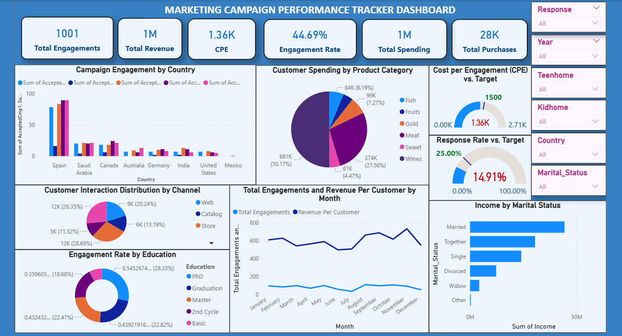

**Conclusion:**The project successfully analyzed marketing campaign performance using customer demographics, engagement data, and spending metrics. The cleaned dataset and interactive Power BI dashboard provide insights into campaign trends, high-performing segments, revenue-generating products, and efficiency metrics like Cost per Engagement (CPE) and Engagement Rate. These insights can help businesses optimize future campaigns, target the right customer groups, and improve overall Revenue.

**Learning Outcomes:**

* Developed the ability to clean, transform, and standardize marketing datasets for accurate analysis.
* Learned to calculate and interpret key KPIs such as Total Engagements, Total Revenue, Engagement Rate, and CPE using DAX.
* Gained experience in visualizing data with Power BI using various chart types: Donut, Pie, Line, Clustered Bar, Clustered Column, and Gauge.
* Understood how to segment customers and evaluate campaign performance by demographics, income, and product categories.
* Applied insights from data to support strategic decision-making and campaign optimization.

**Skill Gained:**

* Marketing Analytics
* Campaign Optimization
* Dashboard Storytelling
* Data Cleaning & Transformation
* DAX Calculations & KPI Development
* Time Series & Trend Analysis
* Customer Segmentation & Performance Evaluation
* Interactive Filtering & Insights Generation